COOK-BOOK SYSTEM1. Introduction

• Project Title: CookBook

• Team ID: NM2025TMID39620

• Team Leader: DHANESH.C & dhaneshdhanesh5854@gmail.com

• Team Members: RANJITH KUMAR.K & rr1089045@gmail.com

– PREM KUMAR.J & jpremjprem21@gmail.com

– JANEESHWARAN.A & jan293229@gmail.com

# 2. Project Overview

• Purpose: The CookBook application is a recipe management system that allows users to explore, view, and learn how to cook different dishes. It provides an easy-to-use interface for browsing recipes, ingredients, and cooking steps.

• Features:

– Recipe browsing and viewing

– User-friendly navigation

– Categorization of recipes

– Responsive design for multiple devices

# 3. Architecture

• Frontend: HTML, CSS, JavaScript

• Backend: None (static web project)

• Database: None (recipes are static content)

# 4. Setup Instructions

• Prerequisites:

– Web Browser (Chrome, Edge, Firefox, etc.)

– Git

– Visual Studio Code (optional)

• Installation Steps:

# Clone the repository  
git clone https://github.com/Hari-sms/CookBook-.git  
  
# Open the project folder  
cd CookBook-  
  
# Run index.html in browser

# 5. Folder Structure

CookBook-/  
|-- index.html # Main entry point  
|-- style.css # Stylesheet  
|-- script.js # JavaScript functionality  
|-- images/ # Recipe images

# 6. Running the Application

• Open index.html in a web browser  
• Navigate recipes using the UI  
• No backend or server setup is required

# 7. API Documentation

• Not applicable (static web application)

# 8. Authentication

• No authentication (publicly accessible recipes)

# 9. User Interface

• Landing Page displaying available recipes  
• Recipe Details Page with ingredients and cooking steps

# 10. Testing

• Manual testing performed by opening pages in browser  
• Tools: Chrome Dev Tools

# 11. Screenshots or Demo

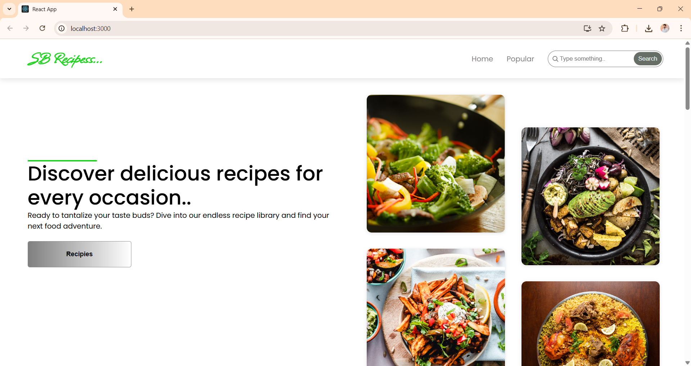

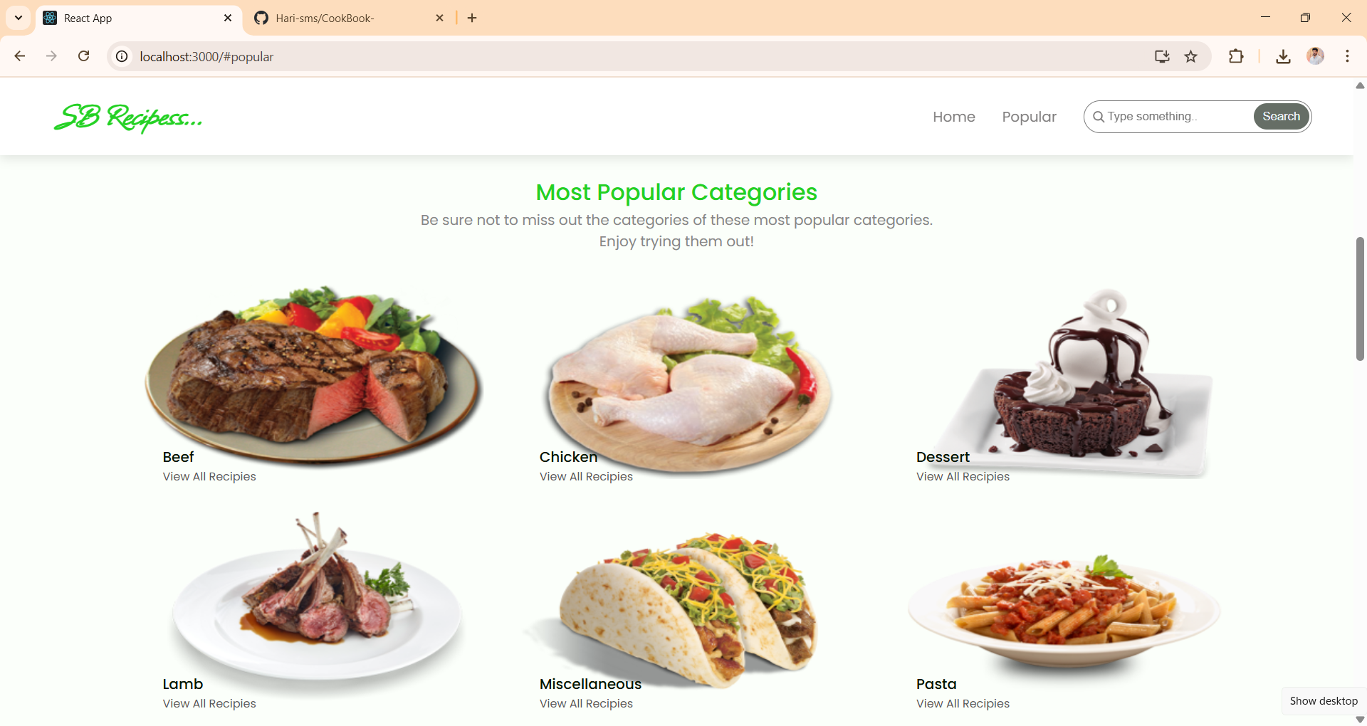

# Demo link : https://drive.google.com/file/d/1YcBLQE6xeiiOAe7JmwzRw9MeY_d2Sh9I/view?usp=sharing

# 12. Known Issues

• Currently no backend or database integration  
• Limited to static content

# 13. Future Enhancements

• Add user authentication system  
• Allow users to add and save recipes  
• Integrate a backend with database  
• Add a search and filter feature for recipes